 **BANNARI AMMAN INSTITUTE OF TECHNOLOGY**

**An Autonomous Institution Affiliated to Anna University - Chennai, Accredited by NAAC with A+ Grade**

**Sathyamangalam - 638401 Erode District, Tamil Nadu, India**

**Student Name:** SANKARANARAYANAN M

**Seat No:** 169

**Project ID:** 10

**Project title:** Bulk Mail Blocking/Unblocking

|  |  |
| --- | --- |
| **Component** | **Tech Stack** |
| Backend | Spring Boot |
| Frontend | React Js |
| Database | MySQL |
| API | RESTful services |

**Technical Components**

**PROBLEM STATEMENT:**

Build a portal system to block/unblock bulk Bitsathy email ID of the students.

**Introduction:**

**Purpose:**

The purpose of automating email ID blocking and unblocking is to streamline the process and mitigate challenges associated with manual *9deliver a user-friendly solution that enhances efficiency, accuracy, and security in email ID management, ultimately improving organizational productivity and user experience

**System Overview:**

**Users:** Admin-Staff manages Bitsathy mail id include blocking/Unblocking

**Dependencies:**

* Integration with Google OAuth for user authentication.
* Consistent performance and availability of the existing email server.

**Key Features:**

**User Authentication**:

* Users log in using their credentials.
* Authentication is successful if the provided credentials are valid.

**Dashboard Differentiation:**

* + Upon successful authentication:
  + Admins are directed to the Admin Dashboard.

**Admin Dashboard:**

* + Admins have bulk action capabilities, including:
  + Blocking or unblocking student email IDs.
  + Viewing the current status of student email IDs.
  + Bulk actions are performed via CSV file uploads.

**Bulk Action Processing:**

* CSV files uploaded by admins are processed by the system.
* For each email ID in the CSV:
* The system verifies the validity of the email ID.
* It checks if the email ID exists in the database.
* The specified action (block/unblock) is executed for each valid email ID.
* The status of email IDs is updated accordingly.

**Admin Email ID Logs:**

* Admins can view logs of email ID actions using filter options:
* Logs include information about blocks and unblocks.

**Flow Chart:**

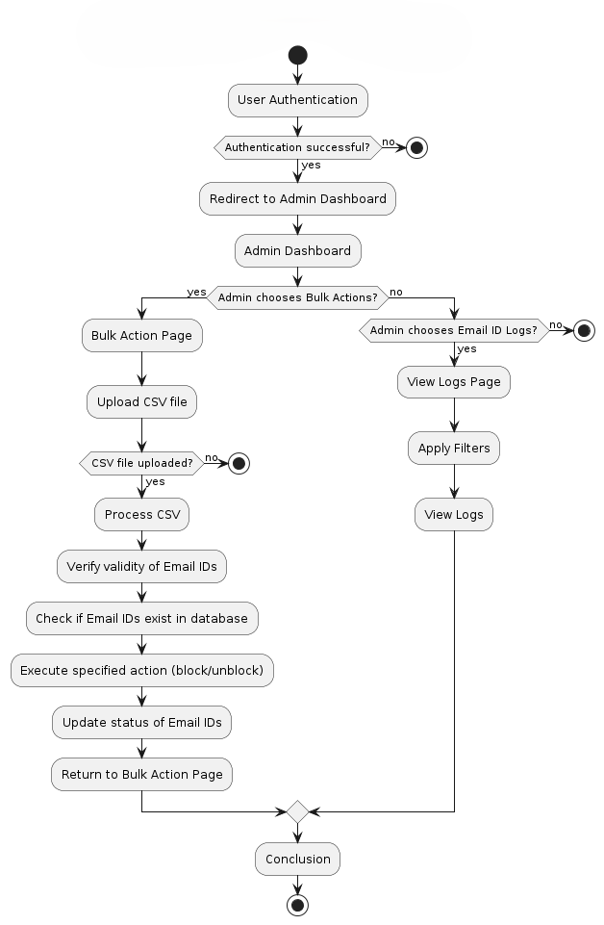

**Work Flow Diagram:**

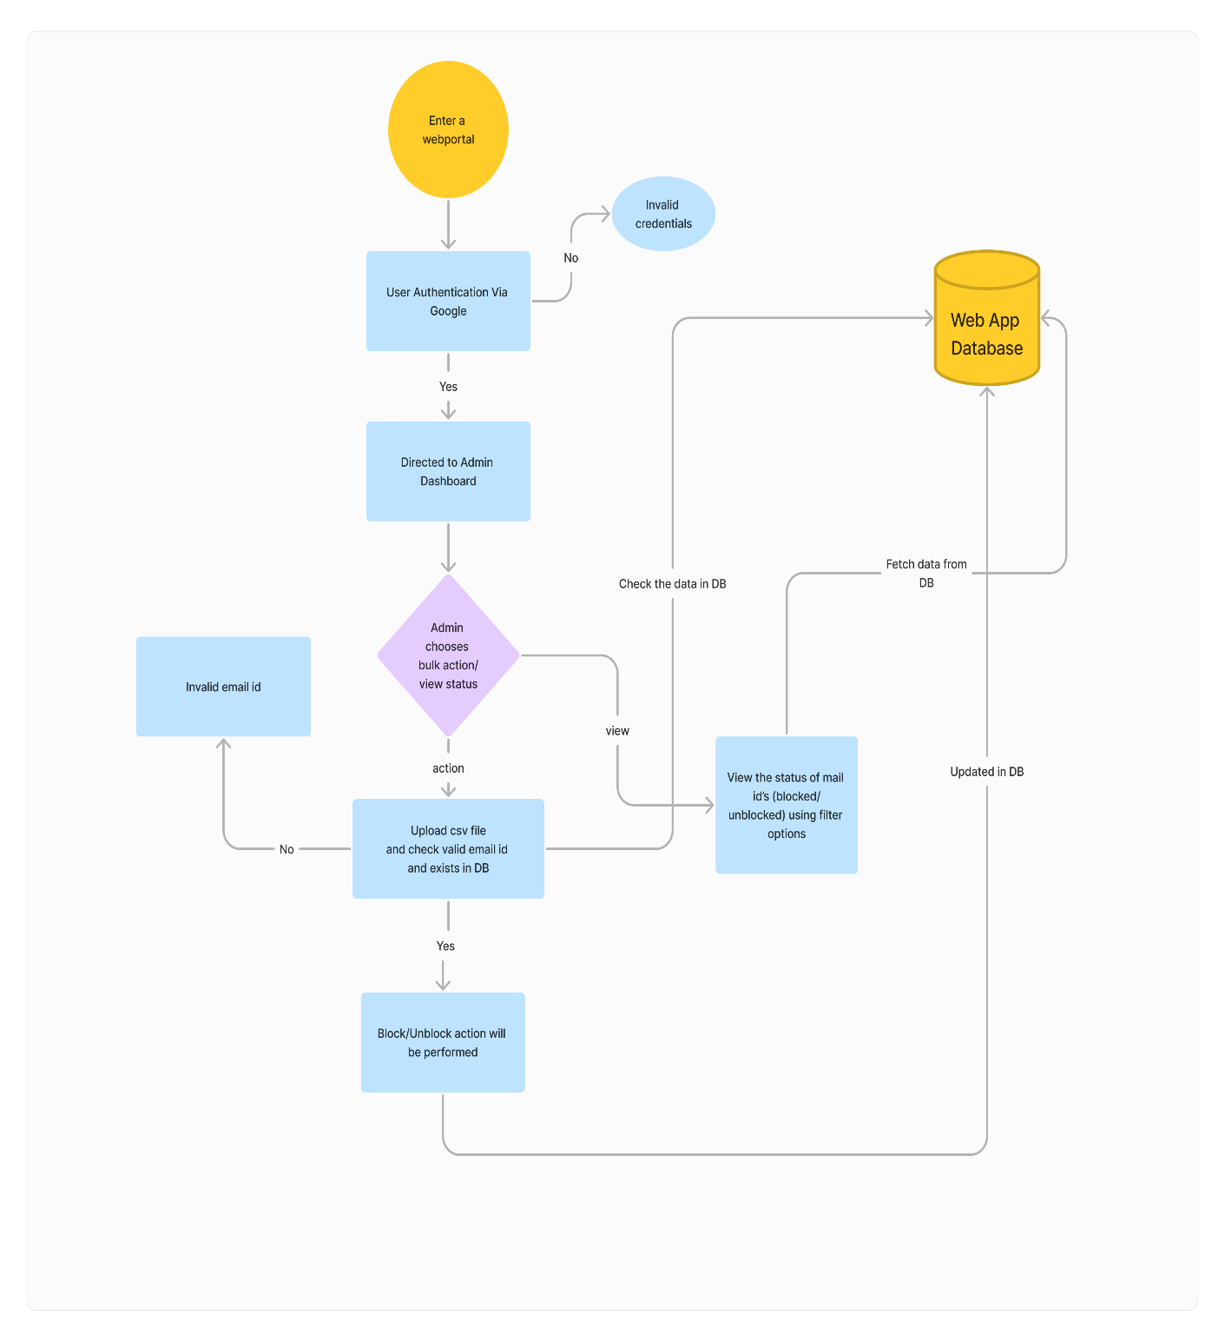

**Work Flow:**

**User Authentication**:

* Implement secure user authentication via username and password.
* Utilize industry-standard encryption protocols to safeguard user credentials.
* Provide multi-factor authentication options for enhanced security.

**Admin Dashboard:**

* + Design an intuitive and visually appealing admin dashboard interface.
  + Enable admins to perform bulk actions seamlessly, such as blocking or unblocking email IDs.
  + Include interactive data visualization components to display email ID status and trends effectively.

**Bulk Action Processing:**

* + Support bulk action processing via CSV file uploads with error handling for invalid data.
  + Implement asynchronous processing to handle large datasets efficiently without impacting system performance.
  + Ensure transactional integrity to maintain data consistency during bulk actions.

**Admin Email ID Logs:**

* + Develop comprehensive logging functionality to record all email ID actions performed by admins.
  + Enable advanced filtering and search capabilities to facilitate easy retrieval of log data.
  + Implement log rotation and archival strategies for efficient storage management.

**User Interface:**

* Design a responsive and accessible user interface with a consistent layout and navigation structure.
* Incorporate intuitive feedback mechanisms to guide users through authentication and action processes.
* Prioritize accessibility standards to accommodate users with diverse needs and disabilities.

**Security:**

* Employ robust security measures, including HTTPS encryption and secure token-based authentication.
* Implement role-based access control to restrict admin functionalities based on user roles and permissions.
* Conduct regular security audits and vulnerability assessments to identify and mitigate potential risks.

**Scalability and Performance:**

* Architect the system for horizontal scalability to accommodate future growth and increased user demand.
* Optimize database queries and data access patterns for efficient performance under high load conditions.
* Monitor system performance metrics and implement auto-scaling mechanisms to ensure optimal resource utilization.

**Error Handling:**

* + Implement comprehensive error handling mechanisms with detailed error messages for users.
  + Log errors and exceptions centrally for monitoring and troubleshooting purposes.
  + Provide user-friendly error resolution suggestions to guide users through problem resolution steps.

**Session Management:**

* + Manage user sessions securely with session timeouts and secure session storage mechanisms.
  + Implement CSRF protection and session fixation prevention techniques to enhance session security.
  + Support session persistence across multiple devices for seamless user experience.

**Data Integrity:**

* Enforce data validation rules to ensure the integrity of input data and prevent data corruption.
* Implement database constraints and referential integrity checks to maintain data consistency.
* Utilize database transactions to ensure atomicity and isolation of bulk action operations.